**Data Analysis on Student Performance**

**Venkatesh Thirunagiri - 16342355**

1. With the histogram of math scores, it becomes easier to analyze the distribution of math scores among students. This visualization allows us to identify the central tendency and spread of math scores.

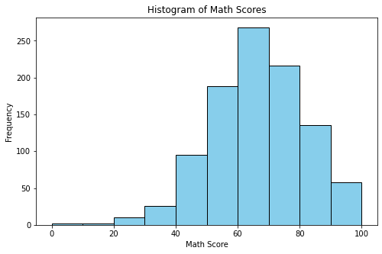

1. With the use of this visualization, differences or trends in reading scores between different demographic groups are found, offering insights into possible inequities in educational results.

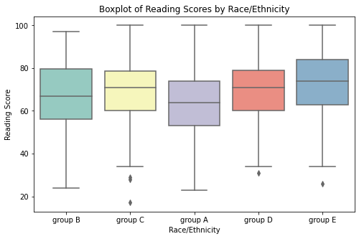

1. More females than males had lunch. There are a higher number of students in the female category than the male category. The most popular lunch type overall was standard lunch. A larger percentage of females had free/reduced lunch than males. A larger percentage of males had standard lunch than females.

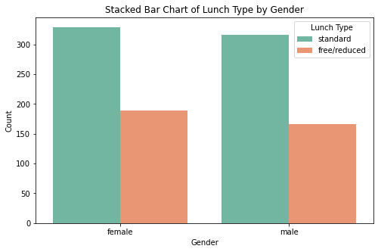

1. This visualization makes it simple to compare how well test preparation materials have helped students perform better, which aids in evaluating the efficiency of such treatments.

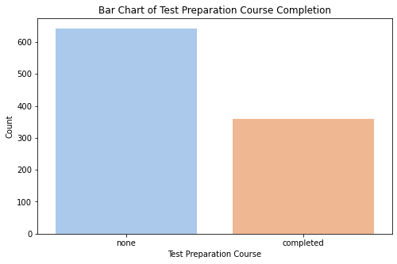

1. It is simpler to evaluate the consistency of performance between these two skills we can clearly see as reading scores and writing scores are correlated to each other

